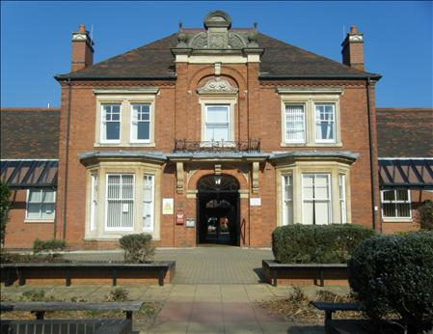
Manor Court Surgery

New Patient Registration Form

Please Note

The new Registration process takes 7-14 days. If you require medical attention before you are registered here you can either:
- Contact your previous GP, if you are still registered.
- Contact the NHS 111 service

Please complete all questions on the form. Only completed forms will be accepted.
PLEASE WRITE CLEARLY

Section 1

Surname ……………………………………………………………………………………………..……

Previous Surname …………………………………………………………………………………..…….

Forename …………………………………………………………………………………………………

Other Names………………………………………………………………………………………….…..

Date of Birth …………………………………….………. Gender M / F (Please circle as appropriate)

Address ……………………………………………………………………………………………..…..…

……………………………………………………………………………………………..………………

Post Code …………………………………….……….

Telephone Number …………………………………………………………………………………….....

Mobile Number …………………………………………………………………………..……………….

Current email address …………………………………………………………………………………..…

Updated August 2023
Section 2

Medical Information

Height…………………………..………….…... Weight……………..……………………….…......
Do you or any family members suffer with the following?
Condition | Self | Relative (Please state who)
Diabetes
Asthma
C.O.P.D (Chronic Obstructive Pulmonary Disease) or Emphysema
I.H.D/Heart Disease/Angina or Heart Failure
Stroke/TIA (Transient Ischaemic Attack) or Mini Stroke
Hypothyroidism
Schizophrenia
Depression/Manic Depression
Epilepsy
Cancer (Please state what form)
Hypertension High Blood Pressure
ANY other problems (Please State)

Smoking Status

Never smoked ………………………………………………………………………………..………..….

Ex Smoker (please give details of how many a day and quit date)

……………………………………………………………………………………………………………..

Current Smoker (please give details of how many a day)

………………………………………………………………………………………………………..…....

Current Medication: (Please list)
Please note all medication will have to be brought with you when you attend your new patient medical.

……………………………………………………………………………………………………………

……………………………………………………………………………………………………………

……………………………………………………………………………………………………………

……………………………………………………………………………………………………………

Do you have any allergies? (Please state)

……………………………………………………………………………………………………………

…………………………………………………………………………………………………………

Section 3

Next of kin Name ………………………………………………………………………………………
Relationship to Patient …………………..................................................................................................

Contact Phone Number ………………………………………………………………………………….

Any other relevant information

……………………………………………………………………………………………………………

……………………………………………………………………………………………………………

……………………………………………………………………………………………………………

Ethnic Origin ……………………………………………………………….………………………….

If English is not your first language, please give details:

………………………………………………..…………………………………………………………

………………………………………………..…………………………………………………………

Carers (Delete as appropriate):

Do you need/have anyone who looks after you or your daily needs? Yes/No

If yes, would you like them to deal with your health affairs at the surgery Yes/No

If yes ask the receptionist about a carers support form.

Permission for a carer/family member to access medical information.

By law your medical information is confidential to you, and we will not share it with any family members/carer without your permission. If you would like a family member/carer to access your medical information, please ask at the reception for an authorisation form.

Declaration
I declare that all the information is as accurate and up to date as possible. I understand that giving false information will be deemed an irrevocable breakdown in communication, and this will lead to me being removed from the practice list.

Signature of Patient ………………………………………………. Date ………………………………

Signature of Parent/Guardian ……………………………………… Date ………………………………
Section 4 – Access to other services on line

More information can be obtained via the Surgery website which is updated on a regular basic. Please visit www.manorcourtsurgery.co.uk

You can also access our on-line triage appointment system (Rapid Health) via the website.

We currently use accurx as a way of communication with patients via a text message service.

Where there is no available appointment that suit you, the surgery may be able to offer you an appointment at our extended hours facility at Red Roofs Surgery.

Section 5 -Additional Roles in the Surgery

You may not always need to see a Doctor for your appointment, this may be dealt with by one of our additional roles. The reception team may sign post you towards the most appropriate Service.

Please see attached leaflet with details of these services.

